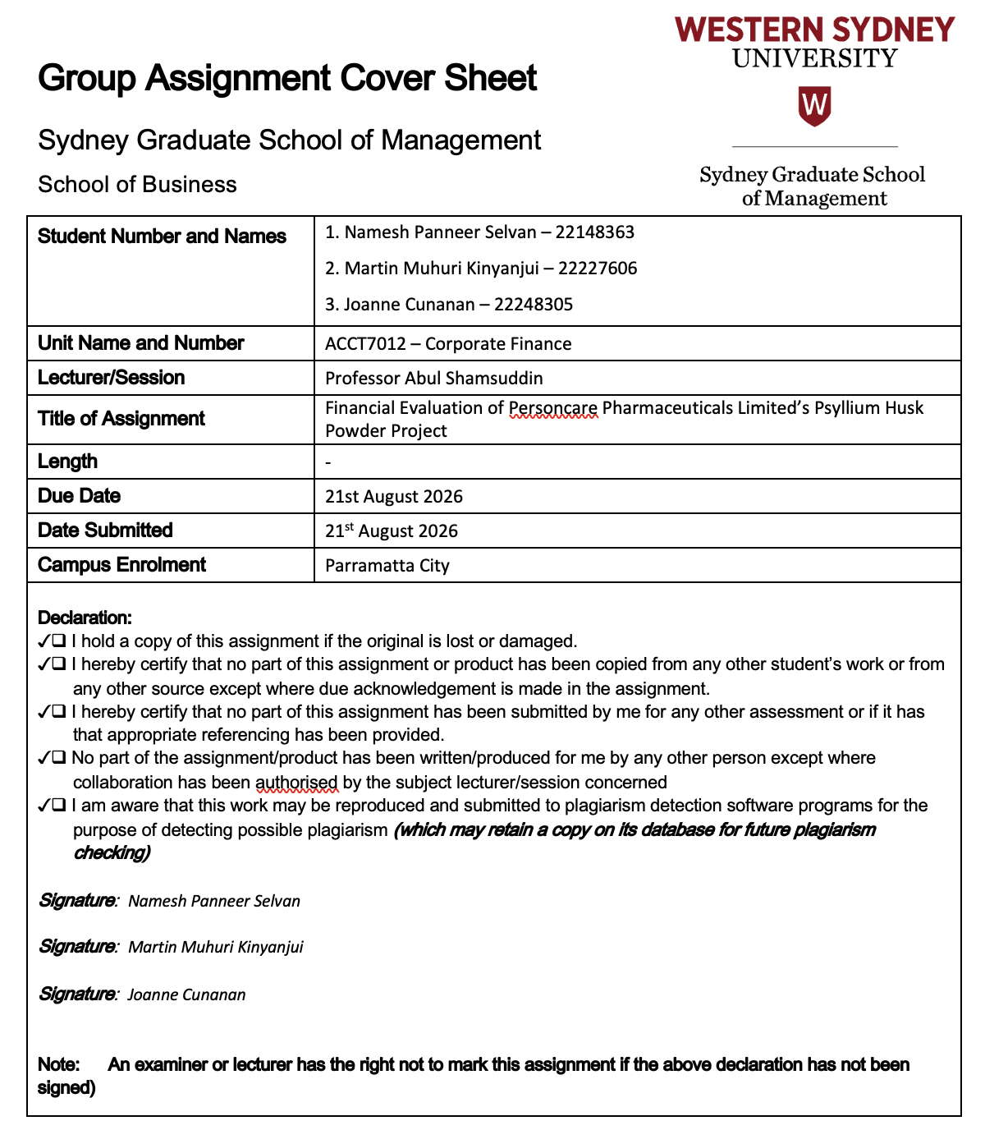

Financial Evaluation of Personcare Pharmaceuticals Limited’s Psyllium Husk Powder Project
Corporate Finance Group Assignment
Table of Contents
1. Introduction 3
2. Cash Flow Identification and Capital Budgeting Analysis 3
2.1 Relevant Cash Flow Assumptions: 3
2.2 Base-Case Cash Flow Analysis: 4
2.3 NPV and IRR Results: 5
3. Executive Summary and Recommendation 5
3.1 Definition of the Problem: 5
3.2 Objectives: 6
3.3 Method: 6
3.4 Key Findings: 6
3.5 Conclusion: 7
3.6 Recommendation: 7
4. Sensitivity Analysis and Strategic Factors 7
4.1 Exclusion of Contract Manufacturing: 7
4.2 Strategic, Operational and Supply-Chain Factors: 8
4.2.1 Supply chain: 8
4.2.2 Operational: 8
4.2.3 Strategic and regulatory: 8
5. References 9
6. Appendix 10

1. Introduction
Personcare Pharmaceuticals Limited (PPL) is assessing a new psyllium husk powder for adults. This proposal requires dedicated manufacturing equipment with building modifications which could expand its consumer-health portfolio and utilise the remaining production capacity through contract manufacturing. However, this may also cannibalise the existing laxative tablet and result in additional operational costs. The report evaluates whether the project creates shareholder value for the shareholders by identifying the incremental cash flows over the nine-year period using it as a base case for calculating NPV, IRR and testing the financial resilience of the project without contract manufacturing and operational risks. Based on recent research the NPV and IRR continue to play an important role in capital budgeting analysis (Siziba and Hall 2021; Sureka et al. 2022).

2. Cash Flow Identification and Capital Budgeting Analysis

2.1 Relevant Cash Flow Assumptions:
The project is analysed using the nine-years of incremental after-tax cash flow of PPL, at 30% tax rate and 18% nominal discount rate. Using straight-line depreciation method, the equipment cost of $1.515 million was depreciated for tax over 12 years, generating an annual tax relief of $126,250. Appendix 1, the cannibalisation figures and account receivables for sales, cost of raw material, increases by 2.5% annually between years 6-9. The maintenance cost also increased by 2.5% after year 5, whereas advertising cost remains capped at $180,000 from year 5.
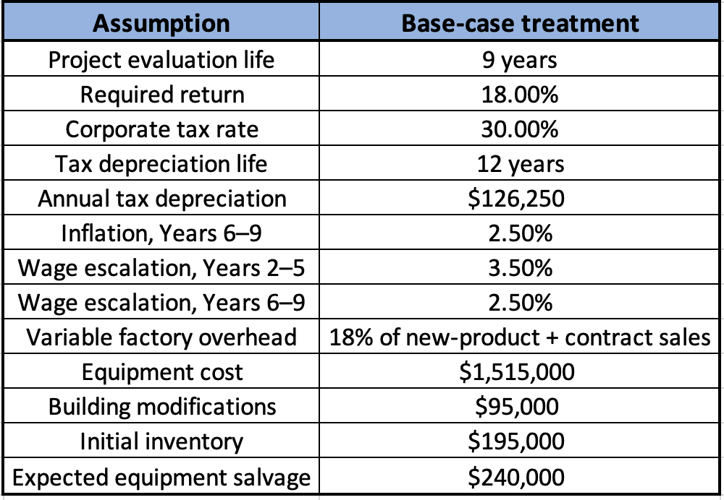
The initial outlay of $332,000 was exempted because it was already incurred and therefore sunk. According to recent study allowing sunk cost to impact future investment decisions can skew corporate investment allocation (Guenzel 2025). The loan repayments of $600,000 is exempted as financing cash flows. The analysis assumes that $95,000against building modification is incurred during project initiation, and $28,500 tax saving is recognised in Year 0.

2.2 Base-Case Cash Flow Analysis:
As instructed by the management, contract manufacturing in included in the base case, where the model embeds with raw materials, cannibalisation net of variable cost, wages, overhead expenses, advertising, tax, working capital and terminal flows with an incremental product cost. An after-tax salvage of $281,625 is included in year 9 and a recovery of approximately $697,235 as working capital.
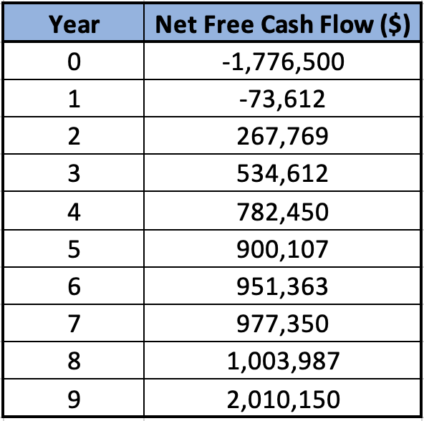
Supporting figures are provided in Appendices A–C.

2.3 NPV and IRR Results:
An NPV of $855,358 was produced using the base case scenario at PPL’s 18% required return and an IRR of 26.45%. The IRR surpasses the benchmark by 8.45% points, with a profitability ratio of 1.48x, where the payback period is 4.29 years and discounted payback is 6.56 years. The measures are broadly used in present-day capital budgeting (Siziba and Hall 2021; Sureka et al. 2022).
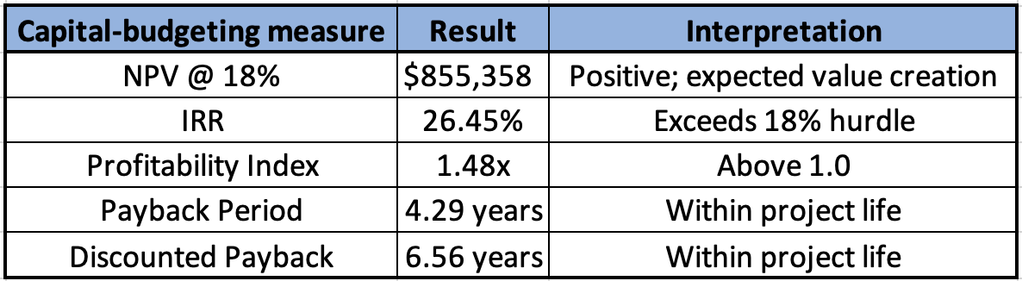

3. Executive Summary and Recommendation

3.1 Definition of the Problem:
PPL needs to finalise on whether to dedicate a gross initial investment of $1.805 million towards a new product where the forecast benefits are uncertain. Only 40% of equipment use is expected initially, making contract manufacturing an integral part. Although the proposed Indian psyllium supply agreement remains on hold, the project will reduce its existing tablet sales. The argument by Jennifer, where prior $250,000 research expenditure should be “justified” and should not affect the uncoverable expenditure. The recent study suggests that inefficient capital budgeting can be due to bias sunk cost (Guenzel 2025).

3.2 Objectives:
The objective of the report is to evaluate PPL’s incremental free cash flows over the nine-year period. Analyse the investment against 18% benchmark rate using NPV and IRR. Identify whether the project is completely feasible in case of complete removal of contract manufacturing and determine strategic and operation cost.

3.3 Method:
The report uses incremental free-cash flow analysis method, where there is a change in the cash flow for accepted projects and excluded for sunk and loan expenditure. The 12-year tax life depreciation is followed, and the accounting depreciation and amortisation of new modifications are ignored as they are considered under non-cash finances. A compromised working capital of $195,000 resulting in increased inventory, with a closing balance recovered by the end of year 9. The disposal of equipment’s is incorporated on after-tax basis, while the annual projected cash flows are discounted at 18% nominal required return. The current capital investment is consistent with the use of discounted cash flow methods (Siziba and Hall 2021; Sureka et al. 2022).

3.4 Key Findings:
The base case offers a robust financial backing for the project, with a $855,358 NPV indicating future discounted cashflow crossing the required investment by approximately $0.86 million and IRR of 26.45% indicating a considerable buffer over the 18% benchmark by PPL. Due to advertising and receivables, the year 1 cash flow is negative. However, it becomes positive from year 2. The project benefits are reduced due to the cannibalisation of the current tablet. By year 9 a recovery is estimated approximately $697,235 under working capital and after-tax equipment salvage by $281,625.
The investment case does weaken by no-contract sensitivity materials. Removing contract revenue like raw material, factory overhead cost and $55,000 Year 1 contract specific wage component reduces the NPV to $295,119 and IRR to 21.00%. The discounted payback increases from 6.56 to 8.28 years and the NPV falls thereafter by approximately $560,239, while IRR falls by 5.45% points. However, NPV remains positive and IRR continues to remain above 18%.
The evidence justifies Anna’s view towards new products, while Tom’s concern remains operationally same because contract work increases the project value. Forecasting risk remains as Anna evaluates new product sales to grow by 6%, whereas John and Miguel consider the sales to go up by 12%. The case specifically identifies these conflicting opinions, although the focus is towards the removal of contract manufacturing.

3.5 Conclusion:
The shareholder value is expected to be generated in this analysis, where the base case highlights a positive NPV and IRR of a nine-year return payback period. The project remains financially acceptable after completely removing contract manufacturing and support independent investment towards new products. However, substantial decline in NPV under no-contract indicates the utilisation of unused space strengthens the project’s margin of safety. Therefore, the financial case is beneficial but highly depends upon the implementation and management of non-financial risk.

3.6 Recommendation:
Psyllium husk powder project should be accepted by PPL, with appropriate implementation conditions. The Indian agreement should be finalised before significant capital commitment and clear targets towards contract manufacturing utilisation. The Board should have early review towards the new product sales, operating cost, contract volumes and working capital. The recommendation totally depends on future incremental cash flow patterns and uncovered sunk expenditure. It is important to treat contract manufacturing as an important booster but limit the condition to have a strong and viable financial investment.

4. Sensitivity Analysis and Strategic Factors

4.1 Exclusion of Contract Manufacturing:
The raw material cost, 18% variable overhead cost, sales are removed under sensitivity analysis to contract revenue and the $55,000 Year 1 contract-specific wage with future escalation. All the other assumptions are held constant.
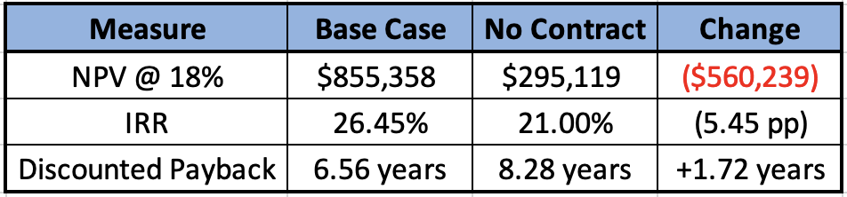
The project is financially acceptable without contract manufacturing, as the NPV is positive and IRR remains positive and IRR is above the required benchmark of 18%. However, the reduction in NPV of 65.5% signifies the additional value accumulated using spare capacity. Anna’s concern towards the uncertain contract forecasts is backed by financial viability perspective, while Tom’s concern towards low utilisation remains.

Strategic, Operational and Supply-Chain Factors:

4.2.1 Supply chain:
PPL is exposed on concentration risk as the proposed psyllium supply relies on one Indian supplier, with the agreement yet to be signed. Heavy reliance on psyllium production in India may create potential supply risk due to agricultural and weather-related factors (Naruka et al. 2019). PPL should therefore secure the supply agreement and keep appropriate safety stock. Fluctuation in exchange rate between AUD/INR currency should be managed as it affects the AUD cost of feign currency payments (Atkin and Harris 2023).

4.2.2 Operational:
Significant proportion of the equipment could remain idle as it initially operates at only around 40% which creates an operational utilisation risk. Contract manufacturing could utilize spare capacity, although the sensitivity analysis shows that PPL should not depend on it to make the project viable. Powder production is a new manufacturing activity for PPL which involves new process, quality-control and consistency risks. TGA requires the manufacturers to ensure that the medicine they produce are in accordance with applicable manufacturing standards (Therapeutic Goods Administration 2026a).

4.2.3 Strategic and regulatory:
PPL must also consider Australian and New Zealand regulatory requirements, especially product classification, labelling and advertising claims. The TGA also oblige manufacturers regarding advertising claims for therapeutic goods to be accurate, balanced and substantiated by appropriate evidence (Therapeutic Goods Administration 2026b). The product’s natural ingredients and reduced side effects provide a competitive advantage, competitors may imitate these features, while some sales may cannibalise PPL's existing tablet product. Thus, PPL should ensure the new product generates significant incremental demand rather than merely shifting existing customers.

5. References
Atkin, T & Harris, J 2023, ‘Foreign currency exposure and hedging in Australia’, RBA Bulletin, 16 March, viewed 21 August 2026, https://www.rba.gov.au/publications/bulletin/2023/mar/foreign-currency-exposure-and-hedging-in-australia.html.
Guenzel, M 2025, ‘In too deep: The effect of sunk costs on corporate investment’, The Journal of Finance, vol. 80, no. 3, pp. 1593–1646, viewed 21 August 2026, https://doi.org/10.1111/jofi.13430.
Naruka, IS, Singh, PP, Haldar, A & Shekhawat, HVS 2019, ‘Cultivating isabgol in rainfed areas’, Indian Horticulture, vol. 64, no. 2, 27 August, viewed 21 August 2026, https://epubs.icar.org.in/index.php/IndHort/article/view/93099.
Siziba, S & Hall, JH 2021, ‘The evolution of the application of capital budgeting techniques in enterprises’, Global Finance Journal, vol. 47, article 100504, pp. 1–18, viewed 21 August 2026, https://doi.org/10.1016/j.gfj.2019.100504.
Sureka, R, Kumar, S, Colombage, S & Abedin, MZ 2022, ‘Five decades of research on capital budgeting – A systematic review and future research agenda’, Research in International Business and Finance, vol. 60, article 101609, viewed 21 August 2026, https://doi.org/10.1016/j.ribaf.2021.101609.
Therapeutic Goods Administration 2026a, ‘Manufacturing for registered complementary medicines’, Therapeutic Goods Administration, viewed 21 August 2026, https://www.tga.gov.au/products/medicines/registered-complementary-medicines/manufacturing.
Therapeutic Goods Administration 2026b, ‘Labelling and advertising for registered complementary medicines’, Therapeutic Goods Administration, viewed 21 August 2026, https://www.tga.gov.au/products/medicines/registered-complementary-medicines/labelling-and-advertising.

6. Appendix
Appendix A — Detailed Year-by-Year Cash Flow Schedule:
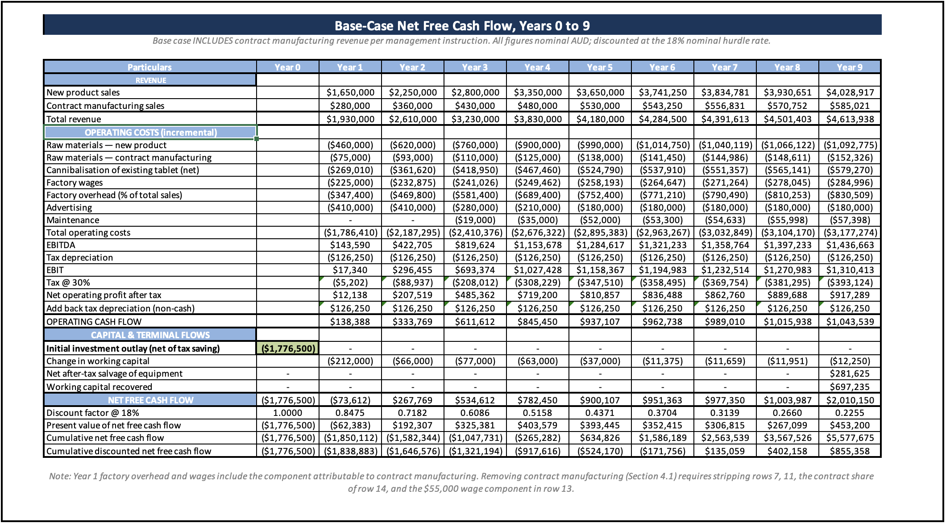

Appendix B — Tax Depreciation and Terminal Value Schedule:
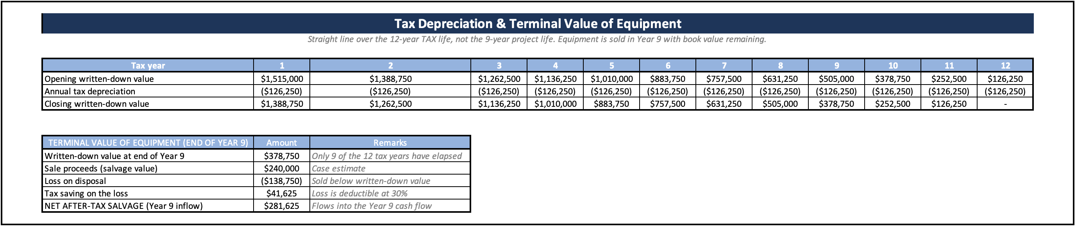

Appendix C — Working Capital Schedule:
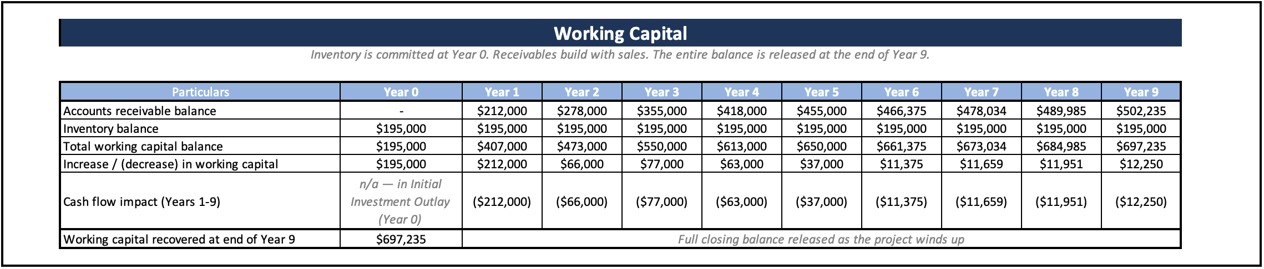

Appendix D — No-Contract Manufacturing Sensitivity:
